**Introduction to Kotlin** 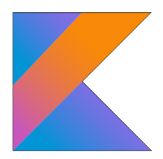

**What makes Kotlin a new and leading programming language:**

* Introduced by industry leaders JetBrains and Google
* Modern, concise, safe, pragmatic and focused on interoperability with Java
* Statically Typed
* Works great with all existing Java libraries and frameworks
* Great for scripting like in JavaScript or in Python
* Perfect for Web design
* Mainly used for Android Apps development
* It’s a Hybrid Programming Language:
  + Functional
  + Object Oriented
  + Imperative
  + Declarative
  + Procedural
* What Kotlin has that Java does not:
  + Lambda expressions + Inline functions
  + Null-safety
  + Smart cast (Type checking)
  + Primary constructor and one or more secondary constructors
  + Operator overloading, to name a few

**Some Mobile Applications written in Kotlin:**

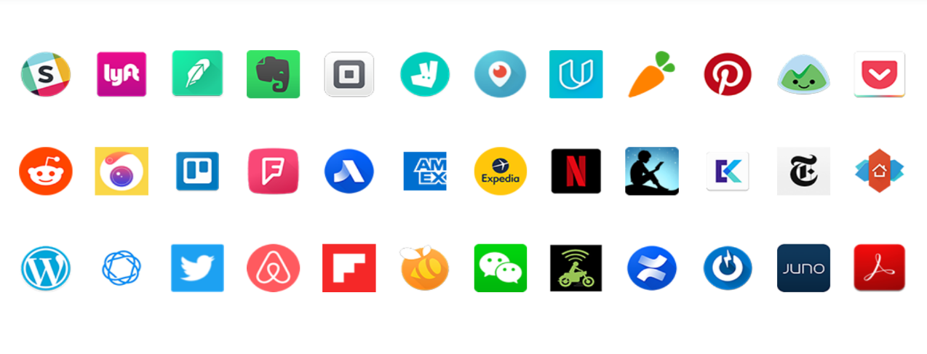

**Places where you can learn more:**

<https://kotlinlang.org/docs/reference/> Documentation, Books, Tutorials

<https://try.kotlinlang.org/> Web based interactive IDE infused with code examples